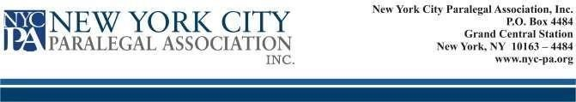
NEW YORK CITY PARALEGAL ASSOCIATION, INC.
PROXY FOR ANNUAL MEETING ELECTION
This is to certify that, I _____________________ _______________________, an
(First Name) (Last Name)
Active Member in good standing with the New York City Paralegal Association, Inc., do hereby designate _________________________ _______________________, to cast my votes for the
following positions:
EXECUTIVE BOARD:
(First Name). (Last Name)
Vice President Angelica Andriani
Secretary Mary Duran
at the Annual Election of the Executive Board of Directors on May 8, 2023. The said __________________ (Name of Proxy)_________________ (Title/Position) is to act as my proxy in voting on this issue only. This authorization is to terminate on May 9, 2023.

__________________________________ Member
Signature
___________________________________ Date

